**Title: Spotlight**

**1.0 Purpose**

Create a spotlight using shaders and visual studio.

**2.0 Method/Results**

I firstly started with my Teapot Project, as it gave me a very good model to show the spotlight on.

In my fragment shader I had to add some new variables to work with, these are shown below;

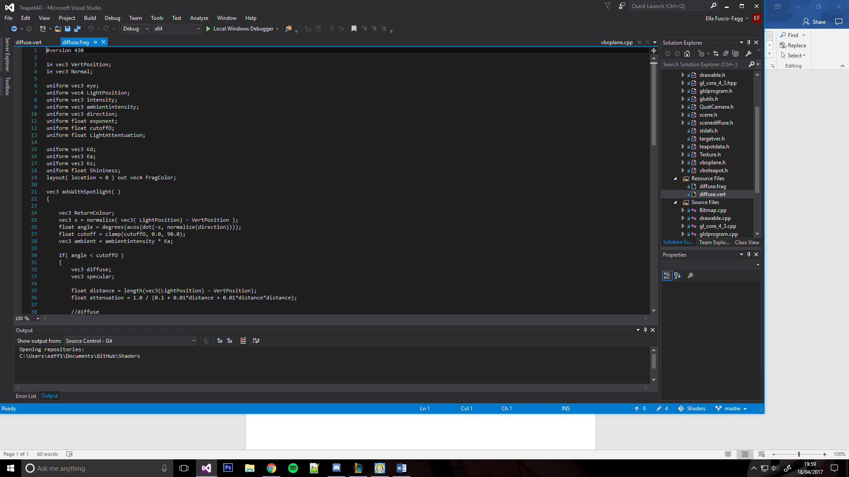

I had to create a cut off function so the light wouldn’t be spread across the whole screen, this created the spotlight effect.

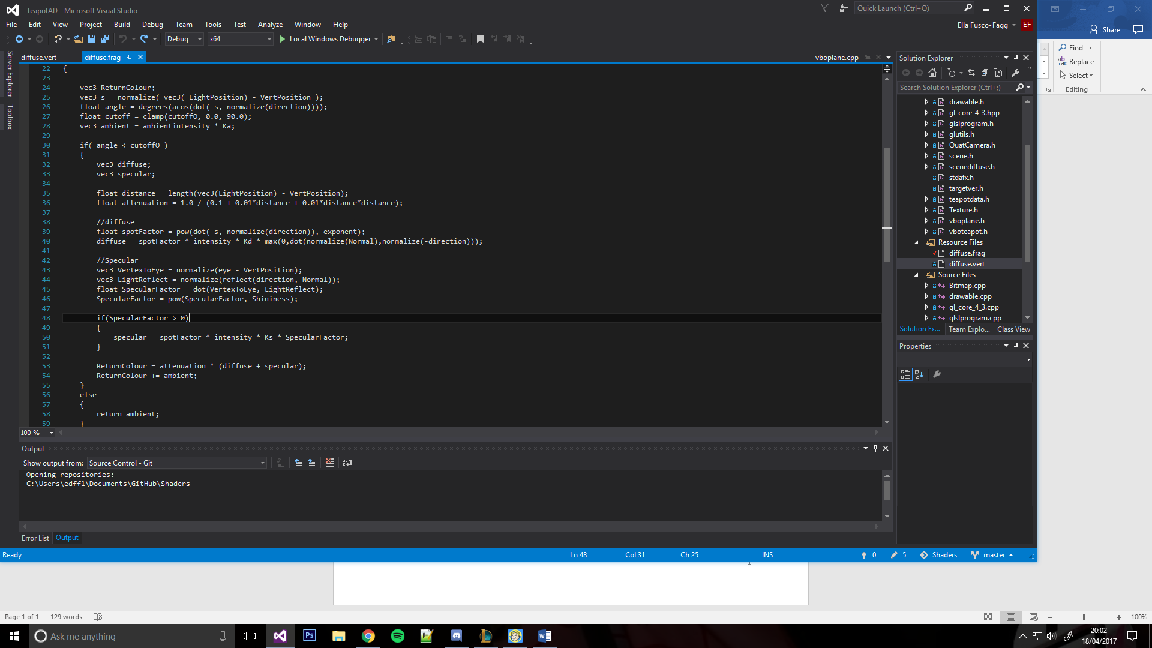

I did this by checking the angle against the cut off amount, and only creating the light within that area, this was all contained within an if statement.

Then I simply used the diffuse and specular light from before, with a few changes;

I set the parameters, these were so I could change the intensity and the cut off for the spotlight, to change how it looks.

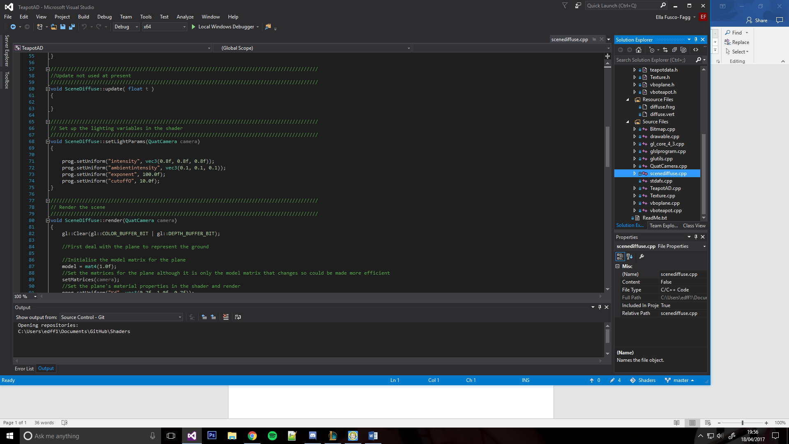

**3.0 Comments/Conclusion**

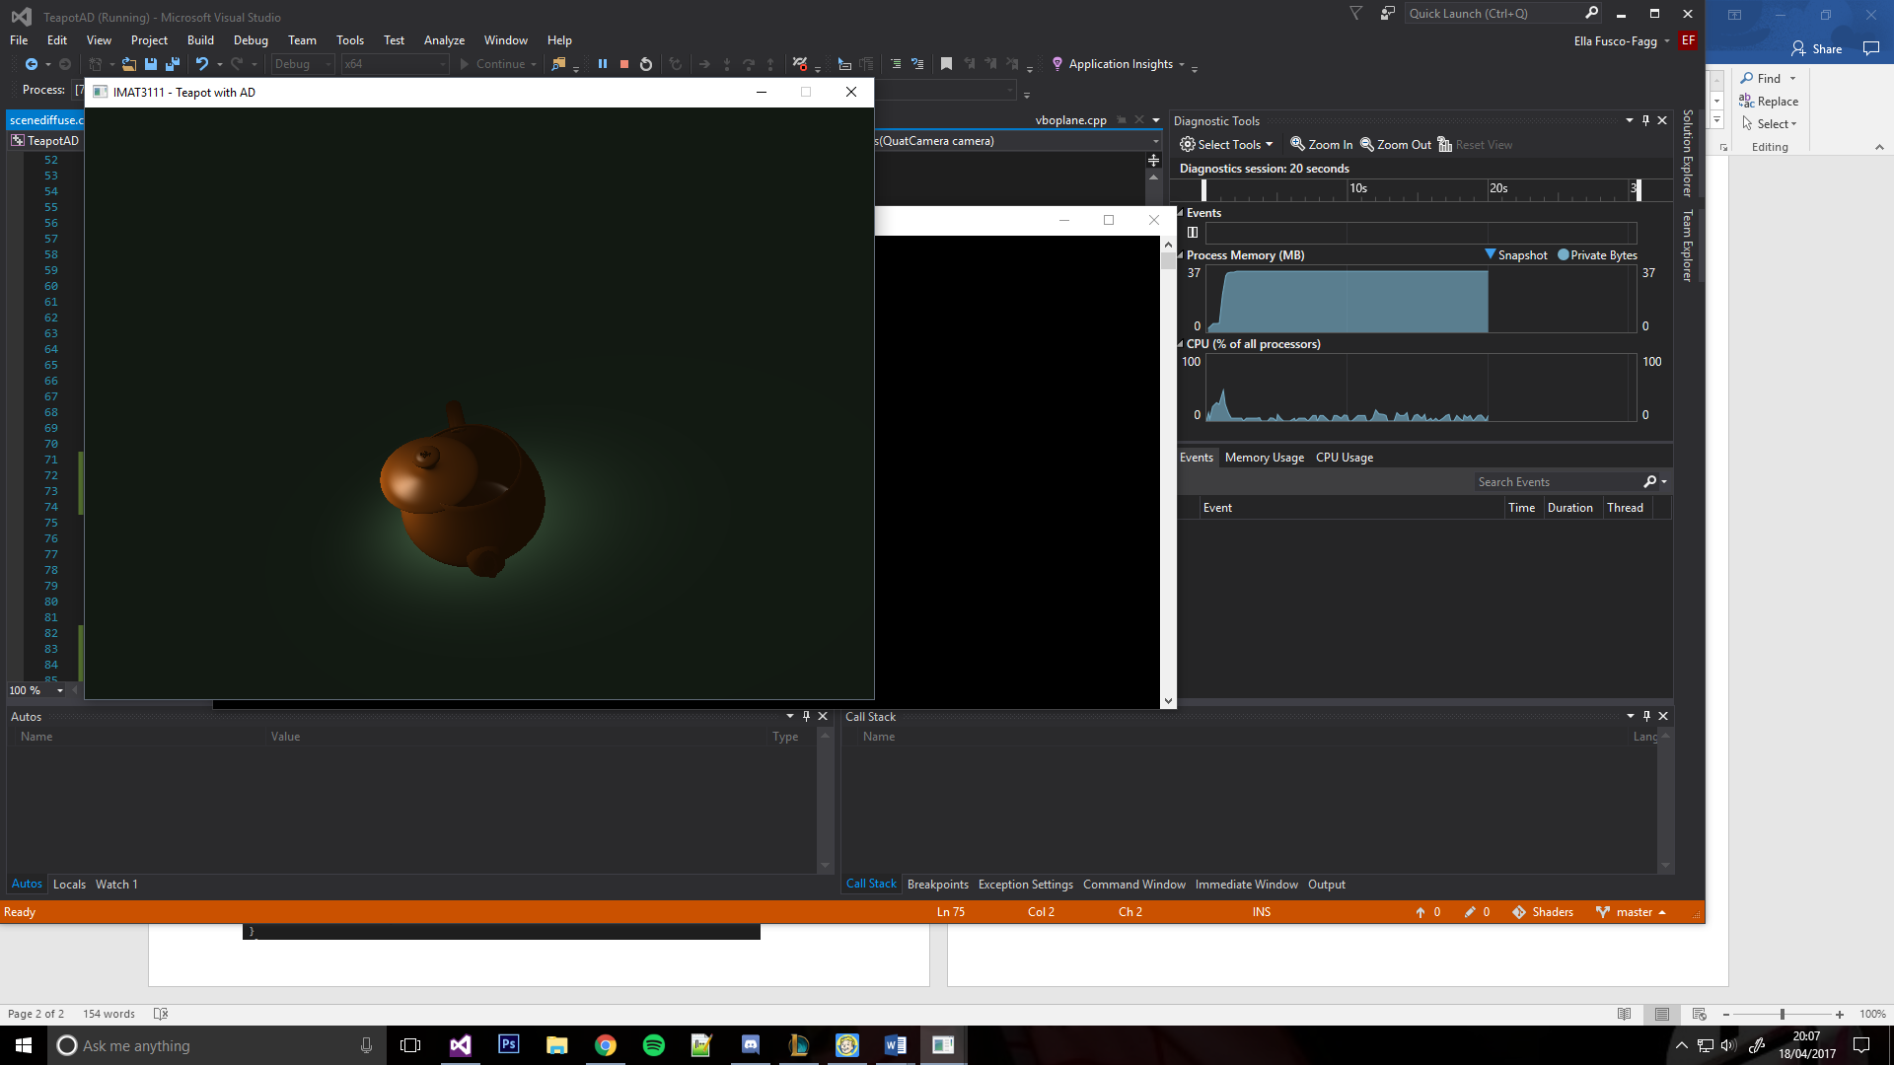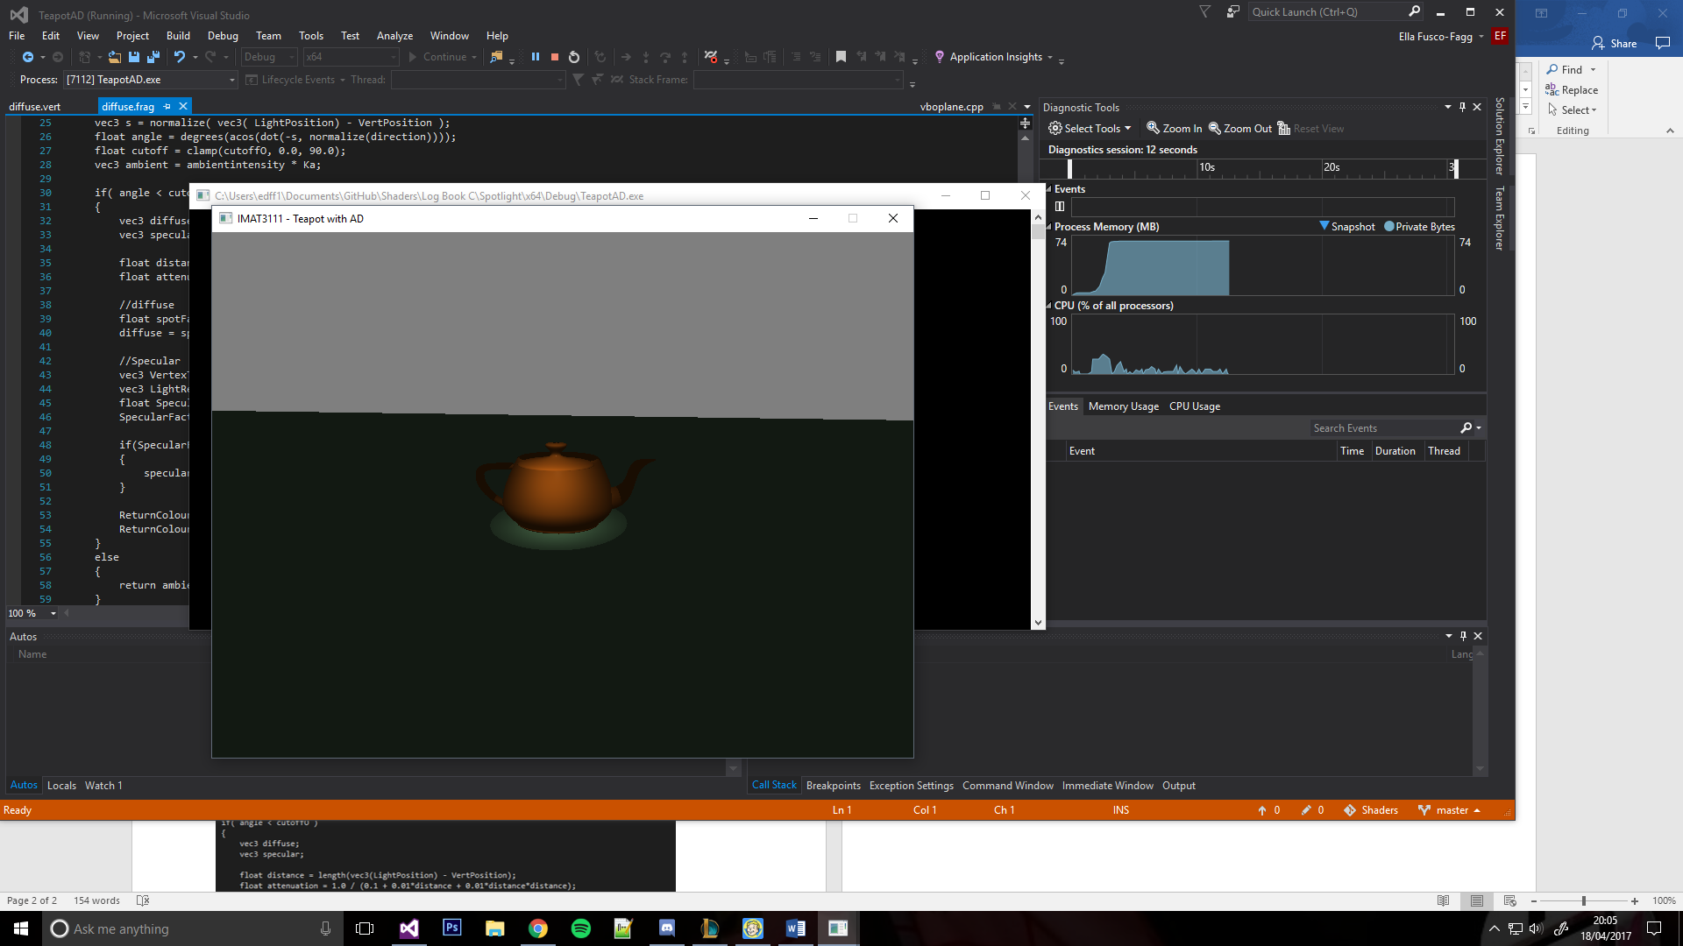Overall I ended up with a pretty good basic spotlight;

Cutoff: 50

Cutoff: 10

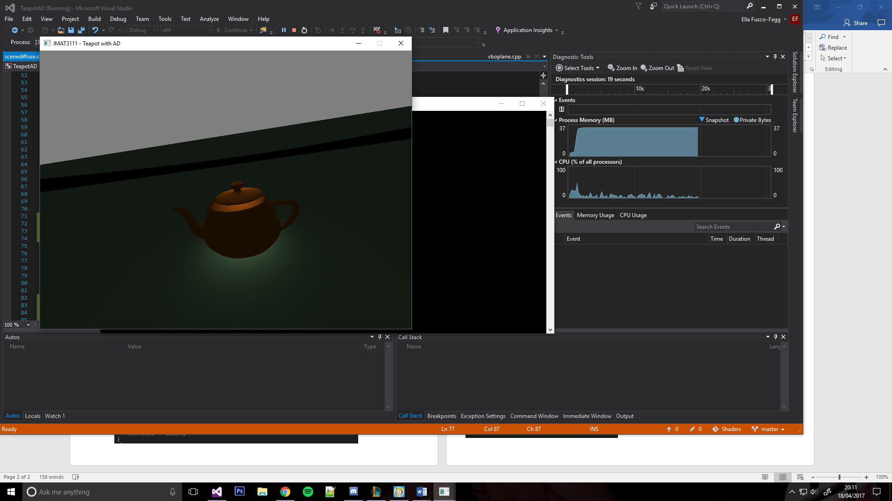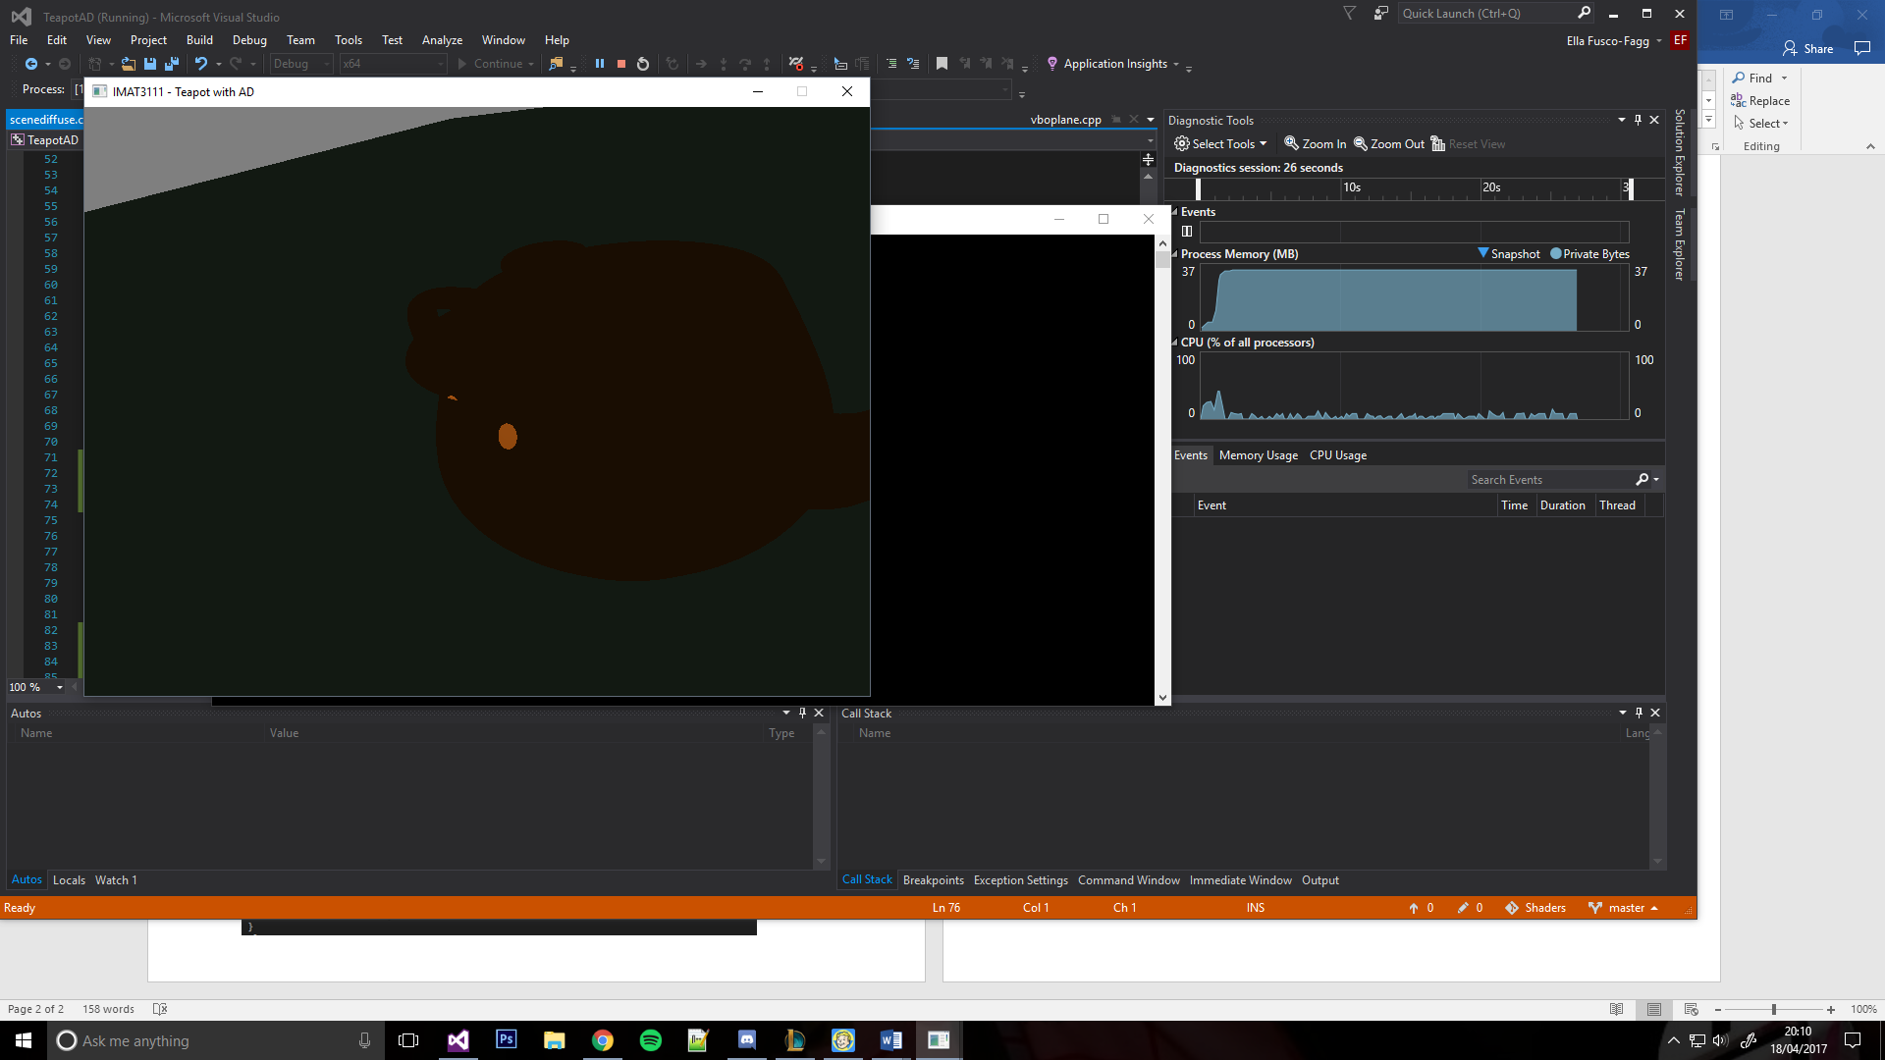

Cutoff: 100

Cutoff: 0.5